1. Install jenkins and run jenkins on port number 8081.

Went to the website and followed the process to install in Ubuntu [Linux (jenkins.io)](https://www.jenkins.io/doc/book/installing/linux/#debianubuntu)  
installed the java:  
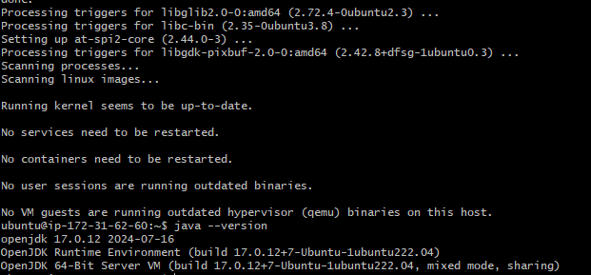

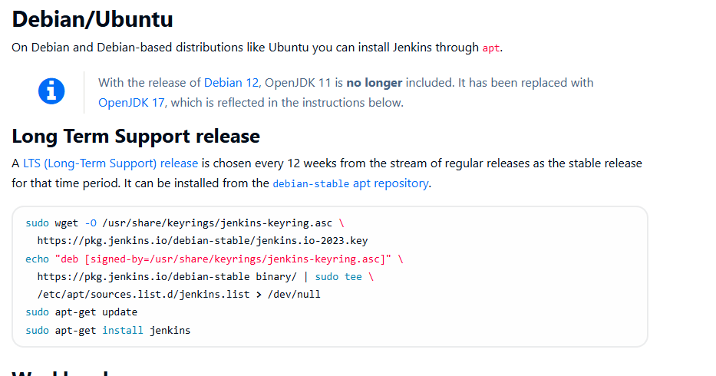

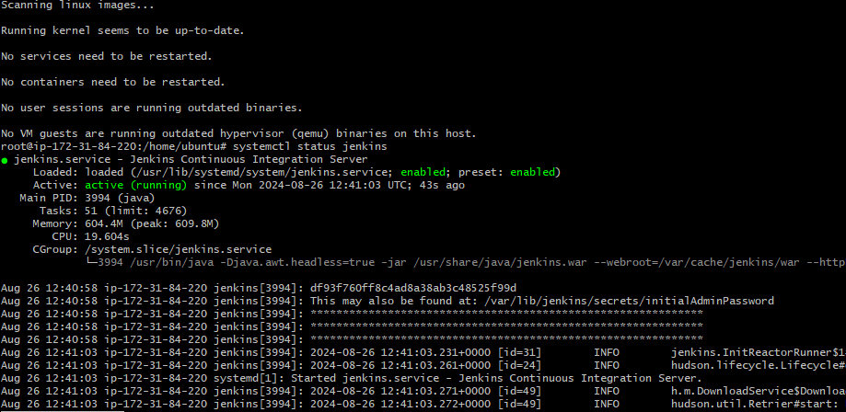

Change the port number in /lib/system/system/ 🡪 vi Jenkins.service  
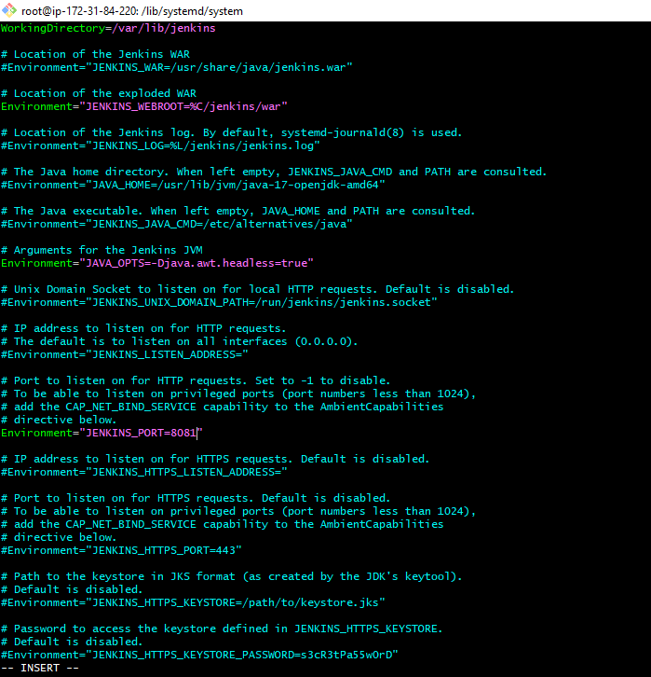

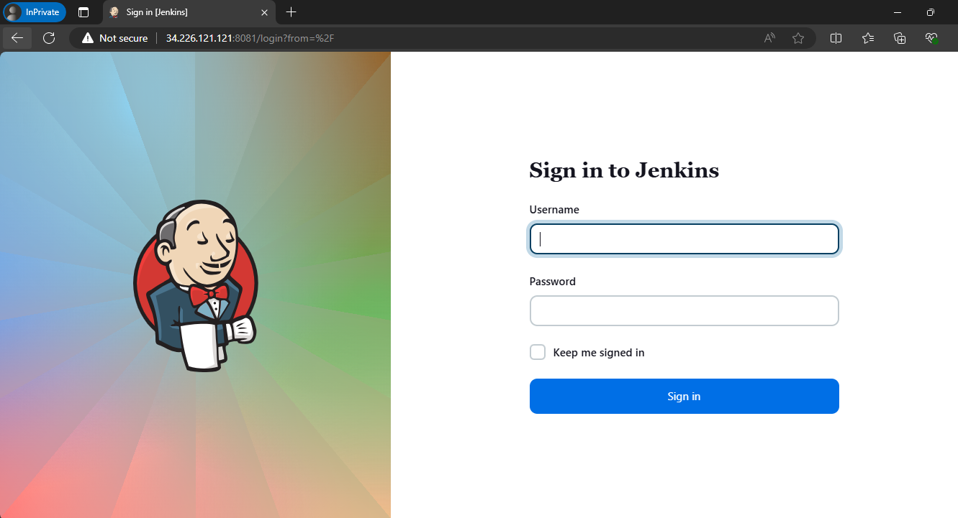

1. Secure Jenkins server:  
   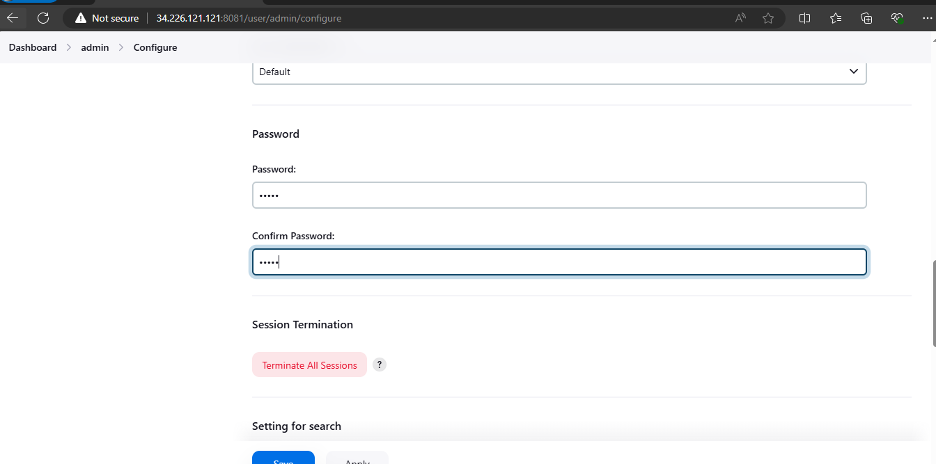
2. Create users called Devops, Testing in Jenkins with Limited access:  
   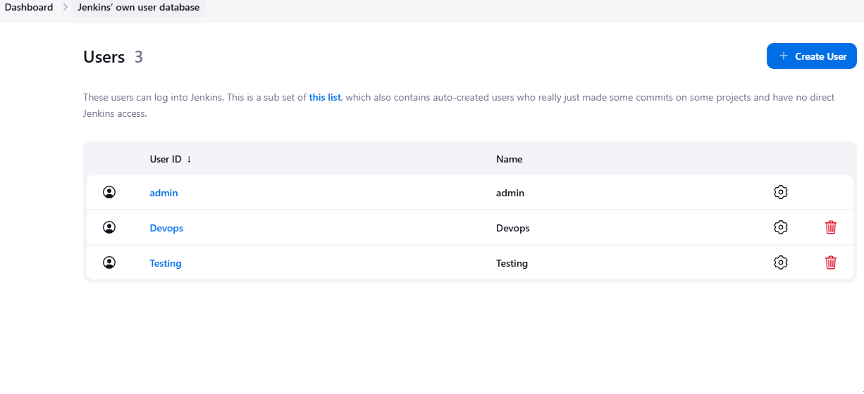  
   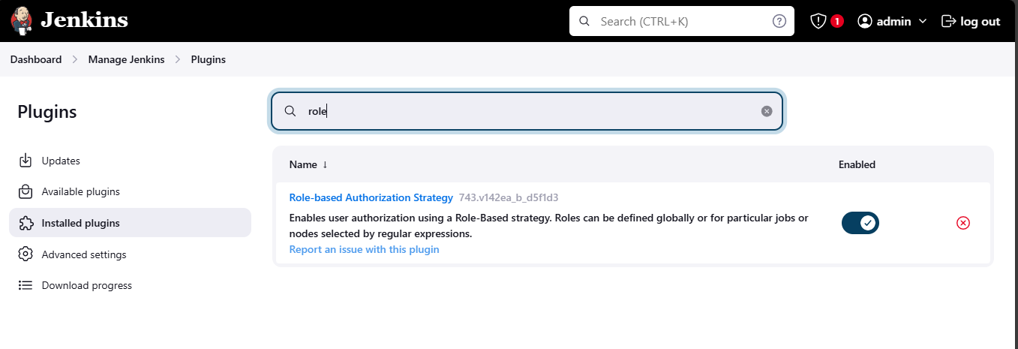  
   gave some sample access: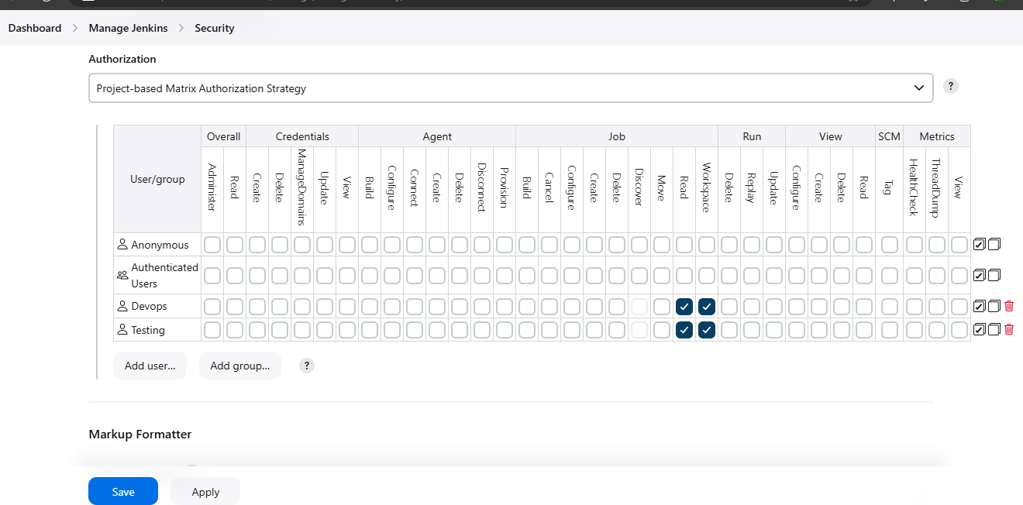
3. Configure labels and restrict the jobs to execute based on label only.  
   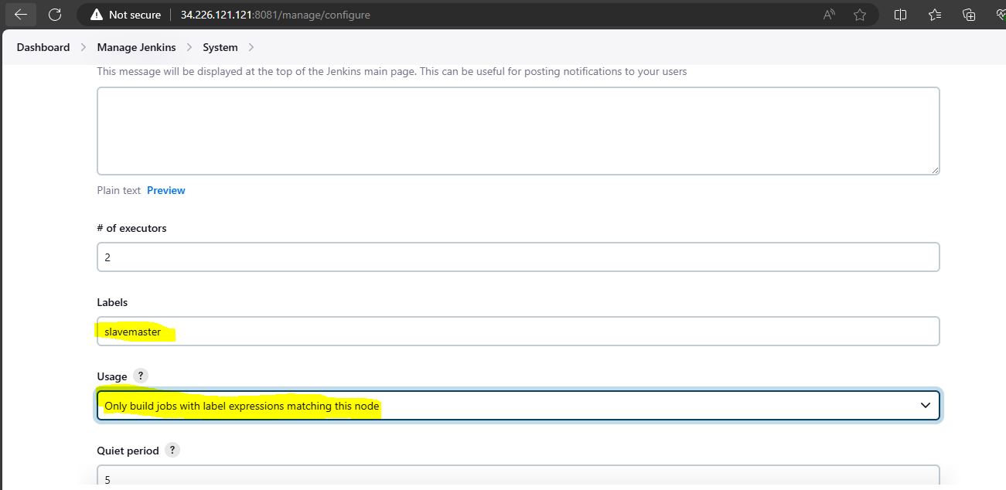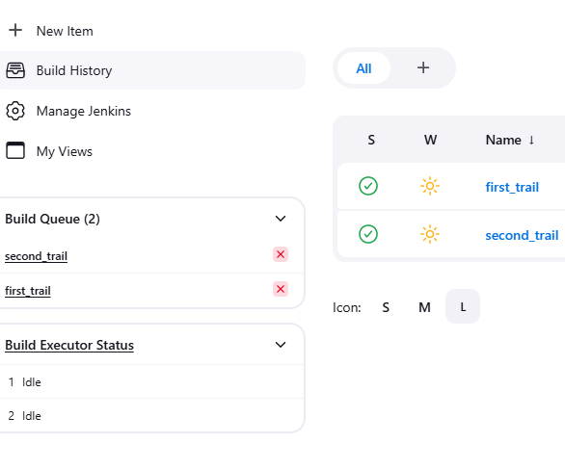

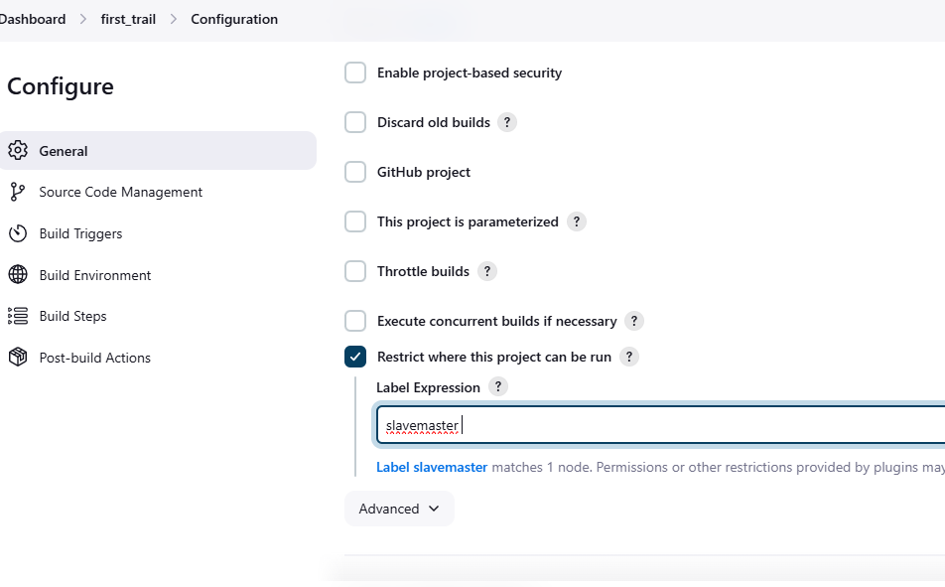

1. Create Three sample jobs using the below URL.
2. <https://github.com/betawins/Techie_horizon_Login_app.git>  
   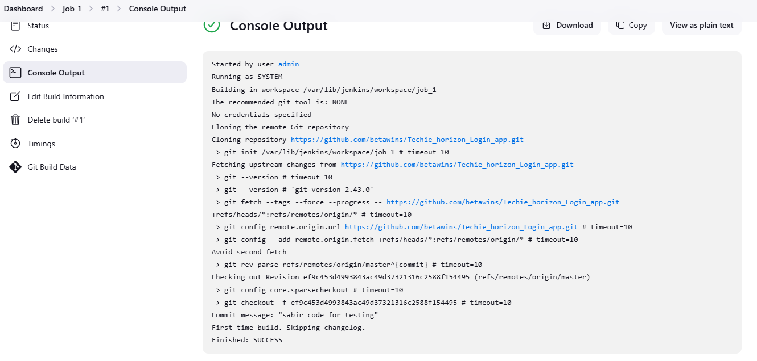  
   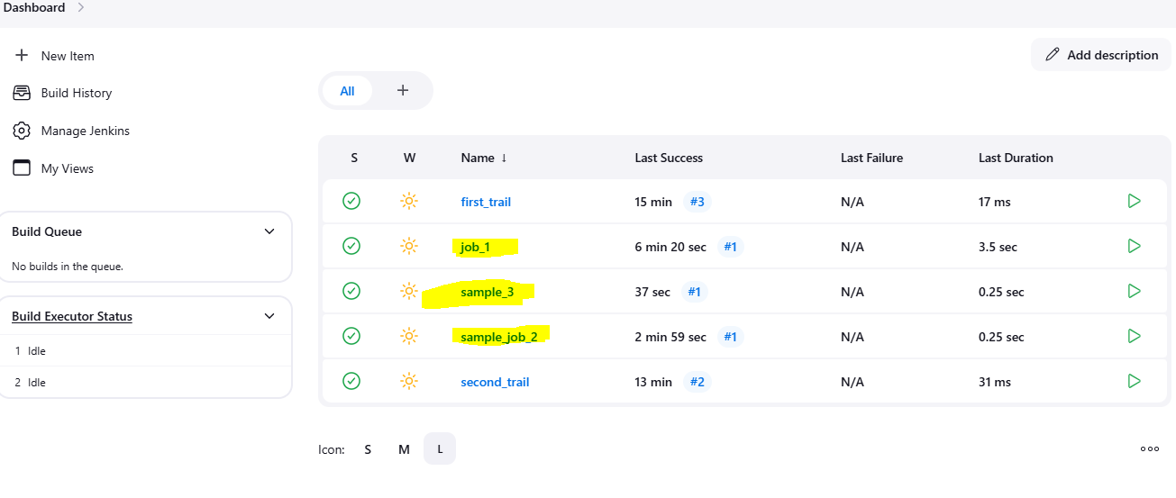
3. Create one jenkins job using git hub Private repository.   
   